Project 1: Application of concepts
(Edit this document as needed)

Partner 1: _______Saaif Ahmed____________

Partner 2: _______John Gonzalez____________

Partner 3: _______________________________ (if needed)

Brief description of first project implemented:
This experiment analyzes the functionality of the breakdown voltage feature in transistors to make a flasher circuit. We observe how component reacts at its avalanche point.

Verification by TA/Instructor of successful completion of project. _______HC______

Two or three Oscilloscope/Excel plots of signals related to your project demonstrating successful implementation.
Voltage of Transistor(x-axis) vs. Current through transistor(y-axis)

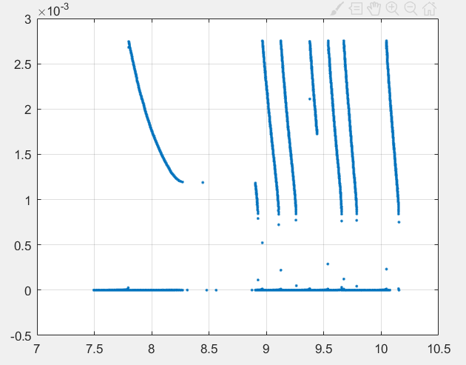
Avalanche point
End of avalanche point
The idea tested here is that the transistor becomes a “negative resistor”. While the idea of negative resistance is obscure, conceptually if a resistor stops current from flowing then a “negative “resistor would allow more current to flow. At the avalanche point of the transistor the current is increasing exponentially. Here on the graph the current shoots up to the max essentially and then dissipates as the breakdown occurs in bursts and is not continuous in our setup.

All Voltages vs. Time
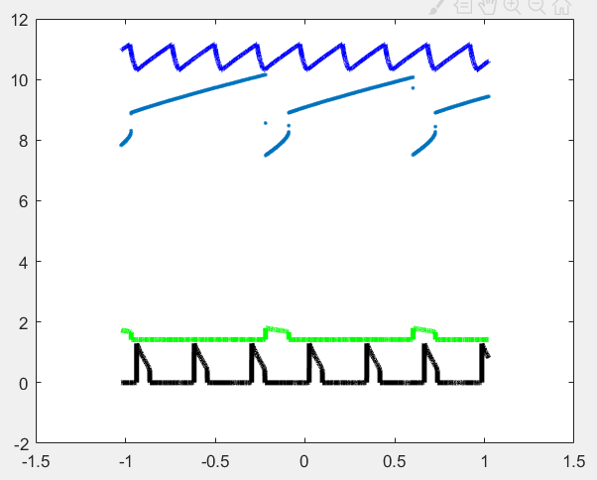
Voltage of Cap
Voltage of transistor
Voltage of LED
Voltage of Resistor
These are the voltages of the four components. The period in time that will be referenced is displayed through the dots. When the capacitor discharges the voltage across the transistor avalanches causing it to become 0. The current shoots up and allows the LED to flash as shown by the little spike on the graph. The resistor becomes a part of the circuit and brings the LED to ground and will not have a voltage unless the cap discharges again.

(If needed) Brief description of second project implemented:
This circuit uses a 555 timer and photocells to alter the sound made through a speaker. Depending on the light intensity the sound will change.

Verification by TA/Instructor of successful completion of project. ______HC________

Two or three Oscilloscope/Excel plots of signals related to your project demonstrating successful implementation.

Plot of the circuit with bright lights.
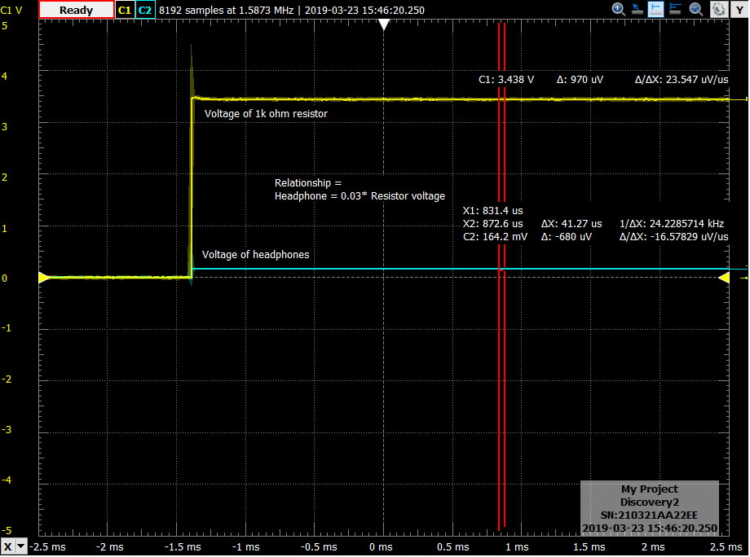
BOTH PLOTS HAVE THE SAME
X and Y axis and same period of time displayed

Plot of the circuit with Dim lights/Darkness
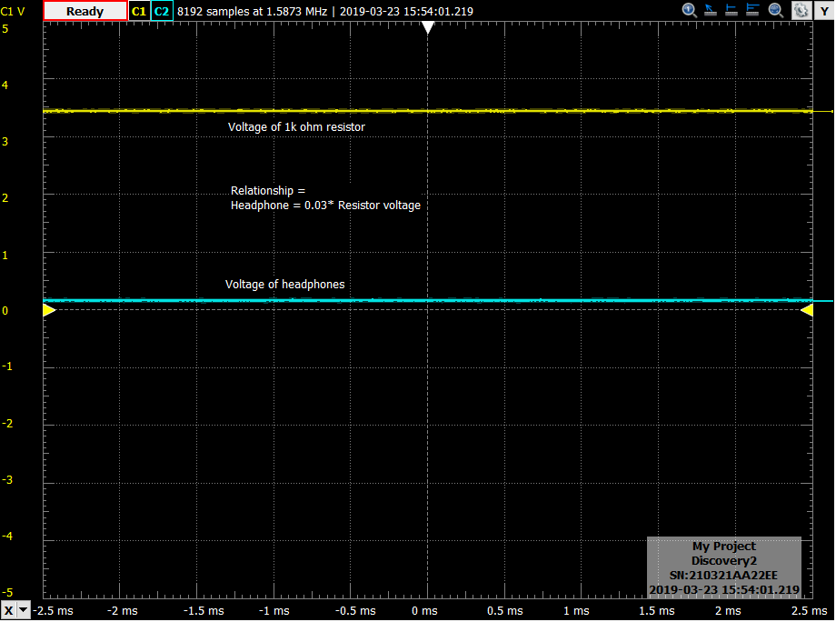

The relationship between the voltage of the resistor and the resistor of the headphones is that the headphones are 0.03 times the resistor voltage. This is consistent within reasonable error of the relationship between the two as given by the voltage divider equation.
The two plots are displaying the output voltages and periods of different light settings. When the light is dark, the on time of the 555 timer is increased, and vice versa when the light is bright. The two plots have the same axis settings so this relationship is visible through the plots.

(If needed) Brief description of third project implemented:

Verification by TA/Instructor of successful completion of project. _______________

Two or three Oscilloscope/Excel plots of signals related to your project demonstrating successful implementation.

